FUNDY PADDLERS CLUB INC
Canoe Tripping Accepted Practices
Version 1.0

AUTHOR: AUTHOR: DATE:
(PRINT) (SIGN) (YY/MM/DD)

VP CANOEING: VP CANOEING: DATE:
(PRINT) (SIGN) (YY/MM/DD)

Foreword

Experienced FPC trip leaders who are looking for the Trip-Leaders checklist (and the forms) may skip to section 3.2.3 for this information.

Otherwise, this document provides ‘accepted practices’ specific to the discipline of open canoe tripping and compliant with the Club’s Risk Management Policy document FPC-RMP.

It also provides some related technical information (in Addenda) for new members, participants on trips, Trip Leaders and Program Coordinators.

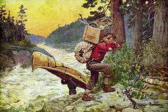

Tripping as a relaxing, meditative experience!
REVISION INFORMATION

Revision Number | Date yyyy/mm/dd | Changes
 | 2015-01-04 | Original document created to cover canoe tripping activities only (not, for example Big Canoeing, canoe dance, canoe racing, etc.), with the following scope of activity:  - Workshops/ practices - fitness or skill clinics assigned Risk category 1)  - Day trips (mostly lake water) usually assigned to Risk category 2  - Multi-day canoe camping trips (Wilderness Rivers up to and including class II rapids. Risk category 3),  - Trips with long stretches of class 3 rapids or class 4 not easily portaged are not covered in this version.

TABLE OF CONTENTS

- Document Scope

- REFERENCES

  - FPC Governing Documents
  - Transport Canada Safety Documents
  - Technical Documents

- RISK Management

  - Concepts
    - Sanctioned activities
    - Risk Categories and their Implications
    - Gear - Checklist
    - Float Plan
    - Pre-Paddle Briefings
    - Post-paddle Report
    - Skills Development and Risk Management

  - Accepted Practices
    - The tripper: En Route - Trip Participation
    - Tripping Coordinator - Trip Sanctioning
    - Trip Leader - Trip Conduct
    - New Participants - Training, Preparing, Participating

- References

- Addenda -- Technical Information from Information Report IR 01
- Club Paperwork - Forms, Tables and Data
- Resources - Books and Web based sources
- 1. Document Scope
The Board has established Policies to foster paddling attitudes and procedures within FPC, aligned, where feasible, with good practices in peer organizations across the world.
These Policies must be implemented in discipline-specific ways. The accepted practices for the Canoe Tripping Program are identified in this document.
The scope of activity covers tripping using open canoes - heavily loaded or not, poled or paddled, on lakes or on moving water not exceeding Class III in difficulty. Accepted practice in FPC narrows the scope somewhat, so that for long distance open-water canoeing (not daytrips) there are suggested minimum length restrictions for solo and tandem canoes, and for the four-man canoes there is a suggested maximum length restriction of 22 feet. At that length, the Big Canoe tradition kicks in with its own regulations and accepted practices.
Therefore, the practices documented here do not cover some topics:
- Canoes not covered: Big Canoes (defined as canoes 22 feet or more in length, or any canoe designed to carry more than four paddlers); very short ‘banana’ play-boats, hard-decked C1 or C2 canoes; Olympic-sprint high-kneelers.
- Disciplines not covered: Canoe dance, white-water slalom (or play-boating), “Brigading” in 6-to-20 man Voyageur canoes, marathon canoe racing (that is, with cruisers or pro-boats- with PFD’s not worn), SUP, and, at present, long distance Coastal Canoeing.
This document identifies accepted practices in the form of information for Program Coordinators, Trip Leaders and Individual Members who are involved in Club Sanctioned activities.

To that end:
- The “accepted practices” permit flexibility in satisfying the Policy.
- Trip leaders and experienced club paddlers are expected to modify the practices if/when conditions warrant.
- Changes to Policy, found in the document RMP will be announced by the President via email and on FACEBOOK and the RMP document will be updated to reflect the changes.
- If members have comments or suggestions regarding the “accepted practices and/or guidelines” they are encouraged to forward them to the VP-Canoe Tripping, or to the Chair of the FPC Safety Committee.

2. REFERENCES

2.1 Policy Documents

GUIDING DOCUMENTS

- RMP - Fundy Paddlers Club's Risk Management Policy. The RMP governs club activities and details the assessment and management of Risk and should be read by members intending to lead trips. It can be found in the Member Archive on the club Web page.

- Introduction to FPC (New Members Document) - This document is an Introduction to programs and Risk management processes for new members and new Board members of FPC. All members should be familiar with the contents of this document.

FORMS

The five key form templates are available on the Club Policy Archive: http://fundypaddlersclub.wix.com/fundy-paddlers-club#!Policy-and-Member-Archive/c14yr/BasicPostsItem2_i3eyvnhu25_2

These forms are also attached as Addendum A here for convenience. Two have been customized for the canoe-tripping environment: the Gear Checklist, and the Float Plan. The latter is mandatory for all tripping activities except for routine practices on protected waters.

Purpose of the Forms

- FORM: WLRC - Waiver of Liability and Release of Claims document. This document is to be read, signed (and witnessed) by all members of the club and any guests that participate in club sanctioned Activities. It releases the club, its BOD, Executives and members of any Liability (within legal limits).

- FORM: PC 1, 2 and 3 - Paddling Gear Check List(s) provide a checklist of gear suggested for trips in different venues or Risk categories. The VP or the Activity Leader may specify part or all of a specific checklist as a requirement for a Sanctioned Activity.

- FORM: PPB - Pre-Paddle Brief is used prior to Sanctioned Activities to provide those involved with the activity additional information pertinent to the activity.

- FORM: FP - Float Plan provides someone at home with a list of all individuals involved with the Sanctioned Paddling Activity in case of emergency.

- FORM: IRF – Incident Reporting Form.

  - TRANSPORT CANADA SAFETY DOCUMENTS

- Boating Guide - TP 9878
  - http://www.tc.gc.ca/eng/marinesafety/tp-tp411-menu-487.htm

- Safety and Distress Radiotelephone Procedures - TP 9878 E
  - http://www.tc.gc.ca/eng/marinesafety/tp-tp9878-menu-662.htm

- Vessel Certificates Regulations - SOR/2007-31
  - http://laws-lois.justice.gc.ca/PDF/SOR-2007-31.pdf

  - Technical References

An Information Report ( IR FPC-01 Technical Information for Canoe Tripping ) is maintained online – on the FPC web Page, member archive. See Section 5.0 here for a description.

From a Risk Reduction perspective it is important to note that there are three areas where sound technical knowledge can help prevent a mishap:
- Paddling skill,
- River knowledge (from experience, and study), and
- Gear.

These are elements in our first line of defense. In that sense, Safety and River Rescue skills are the second line of defense.

That principle (i.e. get good at avoiding trouble) underlies most “accepted practices”. Careful canoe trippers to keep abreast of advances in these topics throughout their paddling careers. The technical information in the FPC-IR-01 Addenda will provide the paddler with a starting point.

2.3.1 Paddling Skill
See Addendum F, G, of IR_01

2.3.2 The River: Canoe tripping and camping knowledge
See Addenda C, E, F, H, I of IR 01.

2.3.3 Gear
See Addenda B, C of IR 01.

2.3.4 Rescues and Cold Water
See Addendum D of IR 01.

- RISK Management

Note: Experienced trip leaders who are looking for the bare-bones trip-leaders checklist (and forms) may skip to section 3.2.3.

  - Concepts

    - Sanctioned activities

The Club's insurance provider requires that all Club activities be "sanctioned" in order for such activities to be covered by the insurance policy. The Club's Risk Management Policy (FPC-RMP) provides the details of the sanctioning process. The accepted practice within Canoe Tripping is as follows: The Annual programs are approved by the Board, but individual trips receive individual sanction after review and approval by at least two people. Within the Canoe Tripping program, which is very dependent on member experience for success, the accepted practice is to bring that experience in, early.

Engaged in this process are:

- The Board (it provides Policy, approves the overall Annual Tripping Program, and authorizes the VP to sanction individual events.)
- The Program Coordinator (usually the VP-Canoeing)
- Experienced club paddlers;
- The BOD Training Officer,
- The Trip Leaders

The following text-box highlights the main features of this process.

BOX – 1. Shared Responsibility for Approving Programs
and Sanctioning Individual Events in the FPC Canoeing Program
Responsibility | Accepted Practice
VP-Canoeing  (or Program Coordinator) | The Program Coordinator has two main functions in this process:  #1 Obtaining Board Approval for an Annual Program  The VP-C draws on club experience to prepare an Annual Program (comprising: trip list, training priorities, gear purchase, budget) for Board review and approval, soliciting input (via planning meetings or email) from experienced club paddlers.  The ‘Annual Trip List’ submitted in early spring, contains some key Risk Management information:  - Locale, duration, date of trips  - Nominated Trip Leaders,  - Prteliminary Risk Categories: The practice is -- most day trips are kept as “RC #2” introductory; and many overnighters are at “RC #3” and so require at least intermediate experience in the stern.  #2 Sanctioning (on behalf the BOD) individual trips  VP-C ensures that within a week prior to each trip date, the Trip Leader provides a comprehensive Trip Notice ; then:  - VP-C reviews it to ensure compliance with BOD RM policy and accepted practice where feasible, and issues it to show publicly that the BOD ‘sanctions’ the event.  - VP-C vets “impromptu trips” nominated by any member and sanctions them if/when they meet the same standard, via the Trip Notice.
Training Officer | The Training Officer reviews the initial Trip List and assesses the need for both immediate and long-term skills and leadership training.  - This may affect the approved Annual Trip list,  - It is an integral part of the long term Club Program Development  - Skills training (in paddling and in wilderness camping) is viewed as a key element in Risk Management, and a fund-raising priority.
Trip Leader | The Trip Leader also has two functions in this activity:  #1. Compile the Trip Notice  The Trip Leader reviews the planned trip and provides the Trip Notice to the VP-Canoeing to issue, containing key safety and logistical information:  - Trip logistics, especially approximate return time  - Known Difficulties: River classification and known hazards; and  - Updated Risk Category (confirms or changes it)  - Skill level expected, and  - Mandatory gear if any.  #2. Conduct (Lead) the Trip  The Trip Leader assigns a Float Plan Holder and conducts the trip. Accepted trip conduct practice is outlined in section 3.2.3

NOTES:
*1) The Vice President(s) and/or the President may remove the sanctioned status of an activity if they deem necessary, thus cancelling the activity.
*2) The Trip Leaders may call upon experienced club members and the Tripping Coordinator for help and advice at any time: Safety is a shared responsibility in FPC.

3.1.2 Risk factors, Assigned “Risk Categories” and Implications

The accepted practice is for the Trip Coordinator and the Trip Leader to independently assess “Risk Factors” and define a “Risk Category” for the activity (trip) as a whole.

Risk Factors

Addendum A, Table A-1, identifies FPC policy on risk factors – the Tripping Coordinator looks at key factors and assigns a preliminary “Risk Category” to the activity based on them.

The trip leader however may consider a larger set of factors; if/as he deems them important, based upon his knowledge and experience, or advice from experienced participants, and on uncertainties in the forecast, up to the time of the trip.

The following text-box highlights a sample set: In practice there is no substitute for experience in choosing the critical factors. In a volunteer club the participants and the Leader together are responsible for safety.

BOX 2. Typical Risk factors considered when planning a trip:

Environmental factors  And Forecast uncertainties | Logistical factors | Human factors
- Water Temperature (Wet suits? Dunk kits?) | - Trip duration (fitness issues, time constraints, experience issues) | - Paddler fitness, experience, and preparation (rain gear? Fitness, etc.)
- Air Temperature and EXPECTED CHANGES in it. | - Remoteness: Access points and distance from Hospital/Rescue | - Guide/ leader /participant  familiarity with the route
- Wind speed and direction AND expected changes. | - Wind Exposure: Presence of wind backstops or refuges (coves, etc.) | - Paddler skills (include assessment of weakest boat) versus the required skills
- Visibility (fog, rain, light), | - Storm layovers: Presence of shelters or lay-over spots for tarps, | - Group Weaknesses: Re: Safety or Communication Skills
- Precipitation and expected changes. | - Landings (take-outs – final and emergency) | - Group Weaknesses: Re: camping skills or gear.
- Technical Difficulty and River state: (tides, currents, flooding, rapids). | - Far up river from the Bay of Fundy: Tide height, rip-speed, un-covered mud-flats, and cold water.

“Risk categories” for trips --- And Implications

Addendum A, TABLE A-2, summarizes club Policy linking Risk Categories to requirements for trip conduct. That policy is the backbone of the sanctioning process and maintains our liability insurance.

Policy defines the minimum expectation, and may be supplemented at the discretion of the Trip Leader, who (for instance) may correct it for a river in flood on the day of the trip.

The Box below, derived from Table A-2, is a comparison of common risk management constraints, showing how they change if/as the Risk Category “RC” is increased with trip risk (and, usually, difficulty). THE KEY CONSTRAINT affected by the Risk Category RC is the prerequisite skill level of the sternpaddler.

BOX - 3. Risk Categories ‘RC’ versus Key Trip Conduct Constraints

Typical  Risk  Category  “RC” | Typical Tripping activity | Key Constraints on Trip Conduct versus “RC”
 |  | Event  Notice | Float Plan | Experience needed? | Sterns-man Skill | P-P Brief
RC #1 | Weekly workshops or practices | Seasonal | Seasonal plan | None or lots—depends entirely on the class. | None if an intro clinic. | it is the coaches decision
RC #2 | Many of the Day trips | TO BE SANCTIONED  It is prepared and issued the week of the trip… but the Annual trip Plan flags it very early in the year. | YES. With FPH. But updates left on car dashboard | YES  Winds ≤ 20 km/hr or Class 1 rapids | YES  Introductory Flat or Moving as appropriate | YES  verbal,  once
RC #3 | Most Multi-day/ or fast-water trips |  | YES. The FPH has the detail. Only minor changes can be left on car dash. | Winds ≤ 30 km or class 2 rapids | YES: Intermediate  - Lake or Moving as appropriate | Yes, verbal, daily
RC  #4 | High Risk expeditions |  |  | Winds ≤ 40 km/hr or Class 3 rapids | YES Advanced | Yes written updated  daily
The Program Coordinator must be aware of potential bias: if Risk Categories are habitually too high, there is little room for beginning paddlers to gain experience.

Options to minimize conflict with inexperienced candidates:

- require participants with inadequate experience to go bow the first time,
- do an informal test before the trip,
- label certain trips as mentored trips ( with extra safety boats, say) where, an introductory level stern paddler is allowed to bash his old Coleman through Little Falls,
- the most likely, is to label only a part of the trip as RC 3 (say) where the inexperienced MUST portage. .

These options should be reviewed with the Trip Leader early in the planning process if it appears there is controversy. In practice the Tripping Coordinator usually will be able help the trip leaders decide the best approach, in advance of Trip day.

Note: Cold Water gear for all Risk Categories

This is BOD policy, and is mandatory on sanctioned trips.
- When T < 15 C Dunk kit is to be readily available
- When T < 10 C wet or dry suits are worn by all;
- For Risk Category #4 (Open canoe trips requiring passage through sustained class 3 rapids, or Team Paddling) – the checklist is not provided at this time. It would have to be developed by the Team.
- Checklists do not include the obvious toiletries, meals and normal clothing associated with any trip but instead focuses on emergency and survival equipment. The member, who is planning for a long trip, should consult the references.

3.1.3 Gear: Tripping Checklists

The club has created checklists to help the Trip Leader ensure that proper paddling, emergency, navigation and communications gear is in place, and to ensure that inexperienced trippers have some basic guidance with selecting appropriate canoeing gear.

The Checklists include Transport Canada requirements as well as practical suggestions for trips of various durations and risk categories.

- The Trip Leader’s Gear list: The “bare-bones” checklist of essential and mandatory gear for all trips is found in Appendix A, Policy Form A-3.

- A comprehensive Canoe Gear list: The comprehensive list of canoeing gear (canoes, paddles etc.) for various sorts of trip is found in Addendum B; and

- A comprehensive Camping Gear list: Gear for multi-day tripping is heavily dependent on the trip, the group, and the time of year, and typical guidelines are found in Addendum C.

    - Float Plan

A float plan is a document that provides someone at home with a list of members involved with a sanctioned activity. The club has a standard float plan available for Trip Leaders in the FPC RMP. A version of it customized for canoe tripping is given in Addendum A, TABLE A-6

Here is the governing requirement excerpted from the Transport Canada Safe boating guide:

"A (float) plan includes your planned travel route and describes (the number and description of the) craft in the trip party. Float plans are also called trip or sail plans. No matter what you call them, you should file one before heading out —even if it is just for an hour or two. File your sail plan with someone you trust and tell them to contact a Rescue Coordination Centre if you are late. “

The accepted practice within the Canoe Tripping program is as follows, where the Risk Categories are used for convenience:

A Float Plan is used for both RC2 trips (most Daytrips) and RC 3 Trips (typical Canoe Camping or whitewater trips) and for higher risk trips, but the application varies: time estimates for longer canoe trips are notoriously imprecise.

1. RC4 trips: For the group paddling expeditions at the RC4 level, the onshore Float Plan Holder ( FPH)_ must know the details even if they change at the trip start: Who, when, where.
2. RC3 Trips: For the routine FPC multi-day or cold whitewater canoe trip, with rapids to class II, the on-shore Float Plan Holder must have the “Final Float Plan” — that is details on all participants no matter whether they pre-register or show up at waters edge. They they can not be recorded in the onshore float Plan, they don’t go. But the FPH will know that small changes ( put in, camp sites, progress day by day, even the take out) imposed by local conditions (river volume) or local knowledge (the guide), may be recorded on the float plan at the last minute, and left on a car dash if communications is limited. However, the FPH calls Emergency Rescue if the group does not confirm they are off water by the agreed date/ time. Communications becomes critical to preventing unnecessary calls to Rescue Services in multiday trips. The agreed “ Trip late time” should allow a tolerance for reasonable uncertainties ( an extra half day at a remote beach, possible wind on open stretches), typically 20% of the estimated duration, but the “unexpected” is best covered with cell phone or emergency communications. See FPC- IR -01 Addendum E for technical information on emergency rescue systems. A PLD is highly recommended for trips exceeding two days.
3. RC2: For the most common club trip—the RC 2 day-trip – the FPH will have "Preliminary Float Plan details… approximate numbers, takeout place and time, take out vehicle License plate or model— but the details covering late arriving participants will be placed on the Float Plan Copy on the dash of the vehicle at takeout. The Trip has only one constraint: Call home before the agreed “Trip Late Time”, with the correct number of people in tow. In between, they explore.

.
The Joint Rescue Coordination Center (J.R.C.C.): (800) 464-1482 or VHF Channel 16) should be called unless the Float Plan Holder hears from the trip leader within an agreed time, say an hour of the agreed trip end.

Pre-Paddle Briefings

A pre-paddle safety briefing encompasses weather, tide, current, medical conditions and communications channels. This document engages all members of the activity and empowers them with the information to call upon emergency resources quickly should an emergency arise. By informing all members of the activity, the group as a whole can make informed decisions. See Addendum A , TABLE A7, for a sample. Download current versions from: http://fundypaddlersclub.wix.com/fundy-paddlers-club#!Policy-and-Member-Archive/c14yr/BasicPostsItem2_i3eyvnhu25_2

Post-paddle Report

An informal post paddle trip report should be forwarded to the VP-Canoeing providing comments and observations to help improve future activities (this can be remarks on the back of the completed Float Plan and Pre-Paddle Brief). In the case of an incident a full incident report should be filled out. A sample of the form can be found in Addendum A , TABLE A8, and the current official version may be downloaded from: http://fundypaddlersclub.wix.com/fundy-paddlers-club#!Policy-and-Member-Archive/c14yr/BasicPostsItem2_i3eyvnhu25_2

    - Skills Development and Risk Management

The first level of defense in any Risk Management program is participant skill and mental preparedness. The Training Officer supports this perspective with both an Annual Training Plan, and a Strategic (three-year, goal focused) Program that has Risk Management as one of its primary drivers.
Club members are encouraged to work towards improving their skills though mentoring and practice, or through formal skills certification courses.
The accepted practices of the FPC Training program include:

- The use of club purchasing power to get 10% - 30% discounts for club members on skills certification courses.

- FPC promotes long term certification programs in canoeing skills, in the six disciplines relevant to Wilderness Canoe Tripping in New Brunswick.

- Lake water (both Traditional and Modern Touring styles),
- Moving Water - Modern Technical MW (with empty canoes),
- River Running - Classical MW (with loaded canoes)
- Canoe Poling
- Canoe Camping
- River Safety and Rescues

- FPC also promotes the most important training process of all: ‘mentored canoe camping’ experiences - by encouraging new paddlers to do canoe camping trips with experienced paddlers and the several Provincial clubs. The key element here is the involvement of the experienced club members in mentoring paddlers new to canoe camping. This process is new and is being developed.

- FPC promotes, for experienced club members – continuous learning programs including certification and refreshers in both:

(a) Advanced Paddling and Camping and Safety skills, and
(b) Trip Conduct skills, leading to Trip Leader certificates and coaching certificates (these are programs in development only).

- FPC promotes in-club Instructor development, when-ever and where-ever good instructor programs can be found.

- FPC arranges off-season and/or early-season workshops in cold water survival and canoe rescues. The Training Officer arranges these through the Safety Committee. See Addendum D for information on cold-water survival information.

The certifying body for skills or leadership certificates may be Paddle Canada or equivalent bodies like the ACA, USCA, BCU, ORCKA, or CKNB

Program Equivalencies

The FPC Policy requires Trip Leaders to filter participants based on paddling skill standards for some trips. The expectation for a participant’s skill standard increases with assigned Risk Category for sanctioned trips. The Text-box below gives some examples of this. That skill often comes from experience and the paddler is known to the Trip Leader; but for new members unknown to the trip Leader, but with certificates, the following equivalencies are useful for determining that prerequisites have been met.

These typical Equivalencies have been taken from the sea kayaking program, but the canoeing program is expected to align in a similar way.

- RM Category 1:
BCU 2 Star - Paddle Canada Introductory- ACA Coastal Kayak II
- RM Category 2:
BCU 3 Star - Paddle Canada Intermediate - ACA Coastal Kayak III
- RM Category 3:
BCU 4 Star - Paddle Canada Advanced - ACA Coastal Kayak IV

BOX: Trip Risk Categories versus Sterns-man Skill

 | Type of Canoe Tripping Activity | Typical Risk category | Pre-requisite participant skill
 | Practices & workshops | RC #1 | None (Novice to advanced according to clinic)
 | Day trips (level 1 rapids),  But cold water, moving water, flooded conditions, high wind, long distances and fog, tide or night paddling may bump the category up. | RC #2 | PC Introductory level – level 1  (Lake, or MW, or Poling)
 | Most Camping trips involving moving water or high wind Wilderness rivers on level 2 rapids, (overnighters on smooth water rivers may be exceptions as RC #2) | RC #3 | PC Intermediate level 2 - MW or LW, Poling
 | White water or team expeditions (sustained level 3 Rapids and beyond) | RC #4 | PC Advanced level 3 Lake or MW

3.2 Accepted Club Practice

3.2.1 The Tripper En-Route – All Participants

Accepted practices within FPC have evolved to ensure all participants share to some degree the responsibility of running a safe and enjoyable trip. Everyone contributes to group safety, in some way, as befits an all-volunteer club. This presumption underlies all the accepted practices discussed here.New paddlers are encouraged to ask questions of the experienced paddlers, the trip leaders, and the Training Officer. There are three areas where all participants of a trip are expected to honour certain common-sense accepted practices.

- Paddler readiness for the level of canoe tripping flagged in the notice: BOX A
- Gear: It must meet an adequate standard: BOX B;
- Trip conduct: Certain practices are honoured by all in a volunteer club: BOX C

BOX A : PADDLER READINESS
- Participants should have a reasonable understanding of their knowledge, and skills and their areas of weaknesses relative to the advertised trip, and should talk to the trip leader if there is any ambiguity about the nature or level of difficulty of the trip in the Trip Notice.
- Any concerns and pertinent medical information should be shared with the Trip Leader BEFORE planning to participate on the sanctioned outing.
- Members must ensure their canoe carries all appropriate equipment for the planned activity and that someone in each canoe has good working knowledge of it. This eases the entry of new paddlers into the sport. The trip Gear Checklist (addendum A) is available from the trip leader.
- All club paddlers are encouraged to work to develop their individual level of Knowledge, Skill and Ability - and to work at improving their understanding of how these factors impact the group.
- Paddlers will actively work at developing ‘anticipation’ ( or trip awareness). Four key questions should become a ritual – a habit of mind:
- How remote is the proposed route and how do I get off it fast?
- What are the fitness requirements (traveled distance and distance to safe pull outs)?
- What are the forecast weather conditions (seasonal and immediate)?
- What type of trip is this (moving-water/lake/coastal), and at what technical difficulty (rapid classification, etc)?
Box B Gear—Meeting an Adequate Standard.
Safety Gear:
Members are expected to be aware of and act in compliance with all safety regulations. En-route:
- Every paddler is responsible to ensure that the canoe (regardless who owns it) is rigged to satisfy the Canadian regulations. (PFD, spare paddle, towline painter, throw rope, bailer and whistle).
- Partners in a tandem canoe discuss this at the start of a trip.
- Most participants in FPC trips have and bring their own paddle, throw bag, PFD, and “day-pack” . See Addendum B.
Paddling Gear: Canoes
These constraints may at times be more than a recommendation. They are rarely applied on short daytrips in sheltered waters. But canoe specifications can, on long trips crossing open water, be a safety issue. . Please honour the Trip Leader’s judgment. For distance or wilderness tripping this is the practice:
- Passengers: Normally there are no more than two persons per canoe if it less than 18 feet long. (On day-trips “family configurations” may be approved by the Trip Leader). The 20 footers handle four adult paddlers easily.
- Hull shape: Use the 75% rule (see Appendix B) if you buy or borrow a canoe. There may be trips where the trip leader will insist that a performance lake canoe with no rocker and low freeboard, is not appropriate for a technical river trip for instance
- Length: Solo
- Daytripping: 12 feet or more for creek paddling, 14 feet or more for open lake.
- Canoe camping OR if you weigh over 200 lbs add two feet each case, if the route is deemed vulnerable to wind.
- Length: Tandem
- Day tripping or Creek ‘paddlin’- 14 feet or more;
- canoe camping trips with open stretches (defined as 30 minutes to shore) or on Class 2 moving water - 16 feet or more;
- big windy lakes or sea or anywhere with one to two weeks of supplies aboard - 17 feet or more.
- And if you will be gone for more than two weeks, and plan to eat, you should be looking at an 18 footer.
- Weight: 55 to 75 lbs for rocky rivers; 35 to 55 lbs for deep-water creeks and lakes. If there are NO portages and you have someone to help you load, ignore this, and bring that indestructible 95 lb Discovery.
- Capacity ( freeboard, loaded): The minimum capacity for canoe camping trips (for paddlers, plus gear, plus food and a wet dog) should be at least 300 lbs (solo) – 500 lbs (tandem) – at which point you still have at least six inches of freeboard. That six inches is important and if your loaded canoe does not have it, repack or get another canoe.
BOX C TRIP CONDUCT

- Members will not ‘wander away’ from the group without signing off from the trip, for insurance purposes – a sensible guideline is to stay within line of sight on average during trips. Certainly, paddlers will try to stay within whistle range of the trip leader and actively share responsibility for the safety of all. Indeed, your safety may not be the issue. The intent is that you are available to help someone else. NOTE: the Trip Leader may allow exceptions as warranted.
- If you cannot keep up, let the Trip Leader know. In cold weather you may be expected to monitor a buddy team. Speak up early. Reassignment of canoes may be required.
- When the line of sight is obstructed on a trip on a moving water river or on a complex channeled smooth water venue, the Trip Leader will ensure there are sweeps and leads, effective periodic check stops, and communications.
- When cold water gear (wetsuits, dry-suits, dry-bags, dunk kits) are identified as mandatory by the trip leader, please respect and honour his judgment.

Our liability insurance coverage assumes compliance with Risk Management policy. More importantly your safety and the safety of your traveling companions depend on it.

COLD WATER
- The Policy Document (RMP) requires everyone to be in wetsuits or dry-suits when the water temperature is below 10C.
- Cold temperatures and wind and dangerous conditions may drive the trip leader to require a more conservative limit.
- A group dunk kit may be required when water T < 15 C. Know who has it and how to use it or ask for training.
- At all times: Wear your PFD.
- Guests: Guests who are not members in good standing of CKNB and/or a CKNB member club , are not covered by the insurance provider. All guests must read, sign and have witnessed a waiver (FPCWLRC) prior to the outing.

    - Program Coordinator – Sanctioning trips

The VP-Canoeing provides oversight at the Board level of club canoeing programs and may be the Program Coordinator of the Canoe Tripping program, in particular. Alternatively a “Tripping Coordinator” may be appointed by the VP-Canoeing – usually as the Chair of a Canoe Tripping Committee. In the tripping context, ‘accepted practice’ usually includes three key tasks.

BOX- 5: Typical Tasks - Canoe Tripping Coordinator

Task | Objectives | Importance
#1 | Program Coordination  - He produces for Board approval the “Annual Tripping Program” ( consisting of ‘activities’, and requests for training, gear, and budget), including the Annual Trip List, . That Trip List accomplishes these things relevant to Risk Management:  - Identifies acceptable venues using input from experienced members;  - Appoints Trip Leaders, and  - Assigns the initial Risk Categories to the listed trips. | See 3.1.1 –Text Box 1. The Program solicits input of experienced club paddlers, the Training Officer, and the BOD.  A sample Trip List is found in Appendix A, Form A-5.
#2 | Technical Review  When appropriate, the TC reviews and approves and issues (“sanctions’) the Trip Leader’s Trip Notice for individual trips, confirming, publically, that compliance with policy is adequate (it meets BOD expectations) | This is the public sanction of individual activities by the club, done usually by the TC on behalf the BOD.
#3 | Risk Management Program Monitoring  The TC then monitors every aspect of the Tripping Risk Management program for the year, and makes recommendations to the President. | This may identify deficiencies in:  - Documentation  - Process;  - Leader training,  - Policy

3.2.3 Trip Leader – Conducting the Trip

The designated trip leader has the appropriate knowledge, skills and experience required to be confident leading the trip in the area and under conditions forecast. An additional ‘guide’ with local knowledge and experience may be used for the area and existing conditions if the Trip Leader or the Program Coordinator deems it appropriate Within the Canoe Tripping program, accepted practices have evolved to include four key tasks for the Trip Leader.

BOX -6 Trip Leader Practices

(Detail, time and place are at the discretion of the trip leader. The Trip Leader quite likely will assign tasks – shuttles etc. - to experienced participants but check for completion).

Task | Practices | Reference
 | Providing a Trip Notice (& Trip Assessment)  This task will include these activities:  - Prepare Trip Notice for the Canoeing Coordinator to Sanction, about one week before the trip,  - Review the Risk Category,  identifying:  - known hazards;  - key factor: required sternsman skill level,  - mandatory gear (if any)  - The gear list can be sent to new members if judged necessary. | Table A4  Tables A4, A5  Table A1, A2  Table A3
 | Safety and Logistics checks (on trip-day).  At the rendezvous or at the put-in:  - Confirm required group gear if any is ready  (example: dunk kit for cold water)  - Confirm shuttles;  - Filter participants by skill level if justified  - Have “guests” sign waivers,  - Update the float plans for late arrivals  (option: have participants sign off)  - Confirm Float Plan Holder is in place (if the activity requires one). | Table A3  Table A7  Table A6
 | The Start: Pre-Paddle Briefing etc.  At the start;  - Request canoe and paddler ‘readiness’ checks (safety gear, wetsuits, etc.) by participants (if/as judged necessary, for say, new trippers.)  - Do Pre-Paddle Briefing and clarify the itinerary, communications/signals, hazard warnings, emergency plans if any, if/as necessary.  - If necessary alert Float Plan Holder of delays | Table A8
 | Conduct the Trip  This may include:  - Identifying sweep/lead boats; location of special kits (dunk kit ), etc. as the river dictates;  - Recap trip rules (re signals, leaving the group, staying together, etc.) as necessary,  - Returning on time, call Float Plan holder within an hour…. or anticipate a rescue.  - Reporting any issues to the Trip Coordinator | Section 3.2.1  Table A9

3.2.4 New Members – Training, and Preparation

A key element in the Risk Management program is attention to paddling skill. Members and Guests should have a good understanding of their abilities and weaknesses. The Individual Club Member's responsibilities are outlined in detail within the Club's Risk Management Policy.

Members should contact Trip Leaders for advice or go directly to the FPC Training Officer if they are having trouble finding information on training. The general practice is to pursue increasing skill/experience throughout your paddling life, in canoe tripping through three ways:

- Mentoring and shared experiences: Ask questions and share knowledge;
- Active skills certification training programs: Contact the training Officer;
- Continual monitoring of the literature: Use Addendum J as merely a starting point.

- References

[1] Heed, Peter and Mansfield, Dick; (Marathon) Canoe Racing, Acorn Publishing, 1992

[2] Ray, Slim; The Canoe Handbook, Stackpole Books, 1992

[3] Dillon, Pamela, Oyen, Jeremy, Canoeing (ACA publication), Human Kinetics, 2008

[4] McGuffin, Gary and Joanne, Paddle your own Canoe, Boston Mills, 1999

[5] Mason, Paul, Scriver, Mark, Thrill of the Paddle, Key Porter books, 1999,

[6] Mason, Bill; Song of the Paddle, Key Porter Books, 1988,

[7] Guillion, Laurie, ACA Instruction Manual, Canoeing and Kayaking, 1987

[8] River Rescue
a) Bechdel, Les and Ray, Slim. River Rescue, Appalachian Moutain Club, 1985
b) Ostis, Nate; River Rescue (Pocketbook) ; Stackpole Books, 2010

[9] Burke, Shawn; Introduction to Paddling Styles (PDF draft on the Maine canoe Symposium web page; See the FPC member archive page: http://fundypaddlersclub.wix.com/fundy-paddlers-club#!Policy-and-Member-Archive/c14yr/BasicPostsItem2_i3eyvnhu25_2 )

[10] Camping technique:
a) Jacobson, Cliff; Camping’s Top Secrets, 1998, Morris Book Publishing,
b) Jacobson, Cliff; Boundary Waters Canoe Camping, 2012
c) Jacobson, Cliff; Canoeing and Camping: Beyond the Basics, Alcon Guide, 2007

[11] FPC IR 01--- Franscis, Ross, Cline Jeremy, Young Evan; Information Report:
Technical Information on Canoeing and Camping Technologies , FPC , 2015

For further books and online web sources see ADDENDUM K
of [11] FPC-IR-01.

5.0 Addenda: Technical Information

This section is a gateway to canoeing and camping technologies, and is meant as an aid to paddlers in understanding the background to accepted practices. (It is easier to revise them on the fly, when the intent is clear!) As the sport evolves, new information and the references (texts and online sources) will be updated online. It is recommended practice for every FPC paddler is to review these references periodically, and to take certification courses where feasible to supplement them.

The information described below is available as an Information Report, FPC-IR _01 – cast in the form of addenda that may be updated individually from time to time by the relevant paddlers or subject matter experts. FPC members are requested to Identify important omissions to the Tripping Program Coordinator. Two key Addenda from that IR ( Addenda A and K) are also attached here.

BOX 8 Contents of FPC-IR -01

Addendum | Subject | Content
 | Club Paperwork | Tables and Forms
 | Canoeing Gear | Technical Information
 | Camping Gear | Technical Information
 | Cold Water and Rescues | Technical Information
 | Navigation/ Communication | Technical Information
 | Long Distance Paddler | Technique and gear
 | Skill Certification Options | - Rescues And Safety,  - Paddling Skills,  - Leadership,  - Wilderness Medicine
 | Inventory of Day Trips—Fundy Region | Trip lists and Data from past trips
 | Inventory of Canoe Camping trips – New Brunswick | Trip Lists and Data from past trips
 | Glossary | Canoe Tripping Jargon
 | Resources | Books and Web Resources

Addendum - A Policy, and Forms from the RMP

POLICY

A-1 POLICY TABLE: Assigned ‘Risk Categories’

A-2 POLICY TABLE: Trip Conduct Implications

FORMS—Customized for Canoe Tripping

A-3 Paddling Gear Checklist
      - A) Clinics, practices
      - B) Day trips
      - C) Multi-day canoe-camping
A-4 Trip Notice

A-5 Annual Trip List (SAMPLE)

A-6 FORM FP - Float Plan

FORMS—All Disciplines

A-7 FORM WLRC - Waiver of Liability/ Release of Claims

A-8 FORM PPB - Pre-Paddle Brief checklist

A-9 FORM: IRF - Incident Reporting Form.

Table A.1 Risk factors Versus Assigned Trip “Risk Categories”
 | Assigned Risk Category (RC)
Risk Factor | #1 | #2 | #3 | #4
Location Examples | Rockwood Park Dominion Park | Musquash Nerpis Marsh | St. Croix River | Offshore Bay of Fundy
Duration | ≤1 Day |  | >1 Day
Shelter from wind | Small Area or well monitored area where all paddlers can be seen by leader, and are < 100 meters off shore or there is a safety boat* present. | Paddling Location is no more than 500m (0.5km) from shore (backstop*). | Wind Backstops or other respites or refuges exist along planned activity route. | There may be no shelter from wind (open water).
Wind | <5.3 knots (<10 km/h) | <11 knots (<20 km/h)  (Or cancel: Leader makes call in protected river environment) | <17 knots (<30 km/h)  (Or cancel: Leader makes the call in protected river environment. | ≥17 knots (>39 km/h
Water Temperature | >10⁰C (See FCP RM Policy for drysuit requirements). | > 15 C or take the dunk kit  >10⁰C OR wear dry suits  or cancel trip. | > 15 C or take dunk kit;  > 10C or use wetsuits | ≤8⁰C (See FCP RM Policy for drysuit requirements).
Air Temperature | ≥0⁰C |  | <0⁰C
Tidal Current | 0-0.5 knots/1km/h. | 0-2 knots/0-3.7 km/h. | 0-3 knots/0-5.5 km/h. | ≥3 knots/5.5 km/h (coastal).
Sea State | Calm. | Breaking chop @ <1m | Breaking Chop @ ≥1m
River Currents |  | Class 1 rapids | Class 1-2 rapids | Class 1-3 rapids
River State |  | Banks not overflowing | Banks overflowing, large standing waves or flooded bush (sweepers)
Landing | Un-interrupted easy landing options. |  | Frequent landing options | Infrequent and often difficult landing options.
Remoteness | Close proximity to hospital (≤ 1 hour) | Close proximity to hospital (<1/2 day) | Delayed response for rescue (< 1 day) | Remote/wilderness (≥ 1 day)
Visibility (Coastal) | Clear | 3nm/5.5 km | 2nm/3.7 km | ≤1nm/3.7 km
Visibility (Inland) |  | 10 boat lengths | 5 boat lengths
Visibility (Night) | Allowed | (Unplanned) | Allowed | Allowed
Table A-2 Trip Conduct Implications versus Risk Category

 | RM Category
Specifications | 1 | 2 |  | 3 |  | 4
Trip Notice | A Trip Notice may be utilized for the season for repetitive paddles under relatively confined conditions | Trip notice is issued normally a week before the paddle: Includes risk category, fitness and skill levels and key constraints.
Float Plan | Head Count | Float Plan and onshore plan holder. Float Plan holder to be contacted within 1 hr. of agree “trip late time” .
Safety Gear | Transport Canada requirements (small craft safety kit). | Gear check lists are utilized with minimum Transport Canada requirements. First Aid Kit, Dunk Kit (below 10⁰C water), additional group gear will be distributed.
Pre-Paddle Brief | Verbal |  |  | Changes reviewed verbally every day
Team Dynamics |  |  |  | Members may be selected for safety roles. (Communication, first aid, navigation etc).
Monitoring | Coach, instructor or designated safety boat. | Trip leader may designate group roles for complex waterways where individual boats can get easily separated and out of sight: Lead boat, sweeper boat, buddy checks in spring
Communications | Excellent coverage through voice or cell phone. | Cell or VHF
Post trip report | FPC-SIRF for incidents. |  |  |  |  | Full report will detail any deviations from the float plan, any close calls and any suggestions for improvements. FPC-IRF will be used for incidents.
Sternsman skill (certificate or equivalent experience) | N/A (Novice etc.) |  | PC Intro (Level 1 lake or moving water as appropriate or equivalent experience |  | PC intermediate (Level 2)- Lake or Moving Water as appropriate…or equivalent experience | PC advanced or equivalent experience, moving or flat as appropriate.

Table A-3 (a) Gear Checklist for local Practices, Clinics, -- within 60 minutes of the city--
Gear | Group | Boat | Each paddler
A) Essential Gear
- Canoe type:
- Identified by coach/instructor/organizer
- Paddling gear (paddles, rope kit, pads, etc):  - appropriate to event & venue (MW, Lake) |  |  | √
- Transport Canada Safety gear  - PFD one per person (appropriate size)  - Bailer  - Noise making device (preferably whistle)  - Tow rope (¾ canoe)  - Throw line (15 m/50 feet |  | √  √  √  √ | √
Items in Categories (4) and (5) can be left in the car or on-shore at the clinic venue except when tours or trips are part of the clinic.
- Personal Gear (as needed)  - “Daypack” or 20L dry bag for the following:  - Drinking water (1 L per 4-hours)  - Light-weight wind/rain/sun gear including hat  - Personal medicines + mosquito dope (baggies)  - Snack /emergency rations  - Dunk-gear: change of clothing - poly or wool-top, pants, and socks.  - if water T < 10C, Wetsuit (or dry-suit), worn! |  |  | √  √  √  √  √  √  √
- Group Gear: Cold water and Emergency  - Dunk-kit if water T < 15 C,  - First Aid kit & Knife  - Communication device (Phone on shore) | √  √  √
B) Paddler Preference: Recommendations for Beginning Trippers - Check the weather forecast and these references: Cliff Jacobson [10a], Bill Mason [6]
Canoeists wear a wide range of foot gear and clothing:  - Feet: Summer Sneakers, sandals, water shoes; Spring/winter neoprene boots and gloves, OR water proofed boots and wool socks (not cotton)  - Head: hat/cap, sunscreen, sunglasses, rain gear  - Core: Shirt, pants, hat: Summer - quick dry gear OR Winter/spring - Poly /wool with or without raincoat/paddling jacket. Below 10C: wetsuit.  - Always AVOID: Blue Jeans, & open-top rubbers! |  |  | √  √  √  √
C) Event Risk Reduction – required at the Coach/Organizer’s discretion
Topo map; & (if fog is risk - Musquash-), compass | √
Weather forecast/update and update capability | √ | Issue: Lightening.

Table A-3 (b) Gear Checklist -- Canoeing Daytrips --
Gear | Group | Boat | Paddler
A) Essential gear
- Appropriate Canoe for venue (per Addendum B)  - Many creek trips—any seaworthy canoe will do!  - But check the “Trip Notice”: a Lake or W/W canoe may be specifically called for, and the minimum length restrictions (e.g. 14/16 ft. solo/tandem) may apply (e.g. trips on big open lakes or Class II rapids like St Croix)  - Adult passengers not encouraged in boats < 18 feet |  | √  √ | √
- Canoe outfitting (paddling & canoe gear): per Addendum B.  - Paddles, spare paddle, ropes, kneepads? Deck skirt? – where/as venue appropriate. |  | √ | √
- Safety Gear per Transport Canada regulations (both paddlers are responsible for this gear)  - PFD one per person (appropriate size)  - Bailer  - Whistle  - Tow rope (¾ x canoe length)  - Throw rope (15 m/ 50 feet) |  | √  √  √  √ | √  √
- “Personal Survival Gear” in “Daypack” or 20 L Dry bag  - Drinking water (1 L /4-hours) or filter  - Lightweight wind & rain gear : See Addendum B.  - Personal medicines + mosquito dope (baggies)  - If water T < 10C – wet suit or dry suit worn.  - Personal Snack/emergency rations  - Dunk clothes: Wool/polypro, top, bottom, socks. |  |  | √  √  √  √  √  √
- Group Survival gear: (Per Addendum C)  - Full Dunk-kit, if water T < 15 C,  - Mini-Survival Kit (First Aid, knife, duct tape, magnetic compass )  - Communications capability (phone or PLB)  - Navigation Capability (Topo map, or GPS, or leader with venue experience). | √  √  √  √ |  | √ (option)
B) Personal Preference: Recommendations for beginning trippers: Check the references for detail: Cliff Jacobson [10a], Bill Mason [6] and Addendum C.
As appropriate/ Feet/ Sneakers, sandals, water shoes OR neoprene bootees or boots + wool socks.
As Appropriate/ Core/ ‘Quickdry’ OR poly/ wool under quick-dry or tight weave wool
As appropriate / Head/: Hat/Cap, sunscreen, sunglasses, etc—as needed
IF appropriate/ Core/ Rain jacket or ‘paddling jacket’. (Wetsuits and quick drys are not shells.)
AVOID: blue jeans, and open-top boots that fill with water.
C) Pre-trip Checks: Trip Notice [ ] ; Weather forecast; [ ] Float Plan; [ ] PT Briefing [ ]

Table 3-(c) Gear Checklist for
Multi-day Canoe trips / Wilderness Tripping
Gear | Group | Boat | paddler
A) Essential gear
- Appropriate Canoe for venue (per Addendum B)  - Lake or M/W canoe? FPC minimum length restrictions (e.g. 14/16 ft. solo/tandem) normally will apply for gear-loaded canoes.  - Participants are encouraged not to bring passengers- stability, & emergency cargo reasons. |  | √  √ | √
- Canoe outfitting (paddling gear): per Addendum B  - Paddles, spare paddle, rope kit, kneepads, maybe grab-loops, deck skirt? – as is appropriate to the river conditions . (Check the Trip Notice!) |  | √ | √
- Safety Gear per Transport Canada regulations  (both paddlers are responsible for this gear)  - PFD one per person (appropriate size).  Safety gear checklist (Per Addendum B) |  | √  √ | √  √
- “Personal Survival Gear” in “Daypack” per Addendum C  - Drinking water (1 L /4-hours) or water filter  - Lightweight wind & rain gear  - Personal medicines + mosquito dope (baggies)  - If water T < 10C – wet suit or dry suit  - Personal day snacks & emergency rations  - Dunk clothes: Wool/polypro - top, bottom, socks. |  |  | √  √  √  √  √  √  √
- Group Survival gear: (per Addendum C)  - Full Dunk-kit, if water T < 15 C,  - Survival Kit + Repair Kit (First Aid, knife, duct tape, compass, etc.)  - Communications device (phone, SPOT, PLB or text enabling Arctec)  - Navigation Capability (Topo map, or GPS, with compass backup). | √  √  √  √  √
B) Camping Gear: Recommendations for Beginning Trippers (for clothing, food, and camping gear) are found in Addendum C. Standard practice options are - each canoe cooking independently OR planned group meals. Ask!
C) Other Pre-trip Checks: - Trip Notice [ ],Weather forecast [ ]; Float Plan [ ]; Skill level Check (re the trip notice) [ ]; Pre-Paddle Briefing? [ ]

TABLE A-4

TABLE | Trip Notice & Sanction—Canoe Tripping
Logistics | WHERE : River_______________________  Putin:_______________________  Takeout______________________  WHEN (Start/finish)  ________________________ __________________________  RENDEZVOUS (PLACE/TIME/Shuttle cost?)  _______________ _______________ ________
Contact Info | CONTACT HOME CELL  Trip Leads (1)  (2)________________ ____________ __________  Float Plan Holder (if known)  _________________(name)___________(phn)
Potential Risks | Forecasts and cautions (if any)  - Wind speed/exposure: _________________________________  - Rapids classification____________________________________  - River state ( level/speed) : ____________________________  - Approximate Water Temperature:______ Wet suits Mandatory?_____  - Other Hazards: _______________________________  Trip Risk Category: __________
 | DETAILS
Mandatry stuff | - Regulation safety gear.  - Group gear?  - Personal gear?  - Skill Levels:_______________________________________________  - Canoe spec?
ISSUE | Notice Prepared by:  _____________________________________  Notice Reviewed and Issued by (BOD rep) by:  _________________________________________

Table A-5 – Sample Annual Trip List

By March each year, the Tripping Coordinator ( the VP-Canoeing or the Chair of the Tripping Committee if one is appointed) presents a program to the Board, for conditional approval, with these elements:
  - Activity Schedule (date, venue, leader, RC): The Annual Trip List
  - Requested Training Support,
  - Requested Gear acquisition
  - Proposed Budget (conditional on fundraising or fees)

Sample: “Day-Tripping” Activity Schedule -- Version 1.0 , 2015

 | Likely  Date | Venues  (Final REVISION/ confirmation date: April 01)) | Canoeing Skill level (equivalent experience) | Trip Risk Category  “R.C.” | Trip Leader
 | Jan 01 | Darlings Island or alternative | Intermediate Lake | RC 3 | Alison H
 | April 19 | Hammond (top end, Water level dependent) | Intermediate MW (or Intro +experince) | RC 3 | Maurice P
 | May 09 | Nerepis (spring run) | Introductory | RC 2 | Nancy C
 | May 16 | East Branch Musqush | Intro Lake skills | RC 2 | Laura M
 | May 23 | Beamers creek ( Hampton) | Intro (lake) | RC2 | Beth
 | May 31 | West Branch hike & paddle | intemediate Lake | RC3 | Evan
 | June06 | Upper Oromocto | Intermediate MW (tentative) | RC3 | Chris K
 | June 13 | Bellisle Creek | Intro (lake ) | RC2 | Evan
 | July 11 | Digdequash Stillwater | Intro (Lake) | RG2 | Alison
 | July 25 | Rusigonish unconfirmed | Intro lake skills | RC 2 | TBD
 | Aug 08 | St Croix (upriver at Milltown) | Intro (Lake) | RG2 | Helen
 | Sept 27 | TBD –World Rivers Day | Introductory Lake | RG2 | Charles G
 | Oct 31 | Nerepis –and Halloween | Intermediate Lake | RG3 | Nancy

Notes:
- Impromptu trips also require Safety review, to get sanction and insurance .
- RC2 trips: The target minimum skill level for the RC2 trips is the PC Introductory level (or equivalent experience) for stern paddlers,
- RC3 trips bring the skill requirements up one level—at the intermediate level in stern. (lake or moving water as required by the Trip Leader)

TABLE A6: Float Plan for FPC Canoe Tripping Program
GENERAL  INFO. | Page 1 of 2  Trip Location: ______________  Trip Leader(s)________________/____________________  Phones:  - Home: ______________/___________________  - On-water_______________/___________________  - Alternate signaling or communications devices:  ________________________________________  Float Plan Holder____________________  Phone ____________________  (This Person is to report to J.R.C.C. when group is overdue by one hour or more, or by the agreed “Trip Late” time. See line C below.)
ITINERARY | - Departure Date (YY/MM/DD)______/_______/______ Time:_________  - Departure Location __________________________________________  - Expected Take-out (end trip) location____________________________ Continue back of sheet if necessary to specify location.  Route  Waypoints (landmarks, stopover points) in likely sequence:  _____________________________________________________  ______________________________________________________  Contingency sites? Possible forced Stop-over Points ( wind, fatigue, etc)
CAMPING Details  (if any) | - Night 01; Where___________________ arrival___________(approximate)  - Night 02: Where:__________________ arrival___________(approximate)  - (Continue back sheet if necessary)
RETURN  DETAILS | A) Expected final take out (Place/date/ time approx):  __________________ _______________ ________ hrs  B) Uncertainties:  - En route decisions: Possible trip delays (side-trips, layovers)  _________________________________________________ (Hours/days)  - Somewhat likely delays or stopovers (wind, water, fitness, navigation) _________________________________________________ (Hours/days)  C) Agreed “trip late” Time C= A+B = _________________ (day/ time)
Pick-up details | - Location of parked Vehicle(s)___________________________  - Vehicle descriptions (Make, Model and License Plate)

Table A- 6 Page 2: Information on Participants

POLICY STATEMENT: Every attempt should be made to have last minute trip members added to the Float Plan Holder's copy of this document. If the Trip Leader cannot contact the float plan holder with the update, a copy with the new members should be left where visible in a vehicle at the departure point.

Summary:
- Number of People on trip_______________
- Number of boats:_________ Total
- Number tandem canoes:____: solo canoes______; kayaks: ______

Boat | Occupants | Boat Spec  (Kind, colour/ length) | Emergency Contact and number | Issues (if any) and signature.

Table A-7 FPC Waiver—SAMPLE ONLY. Download current version
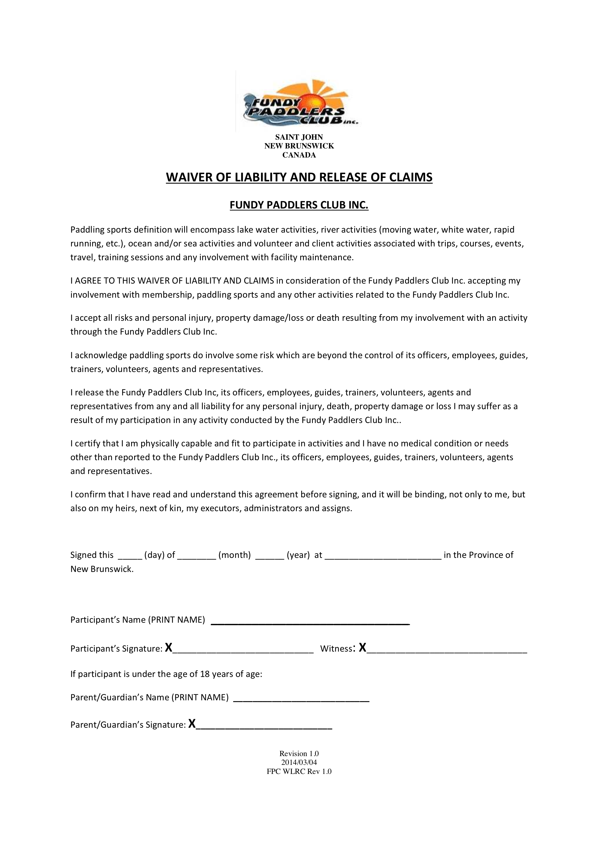
Table 8 Pre-paddle briefing – SAMPLE. Please download
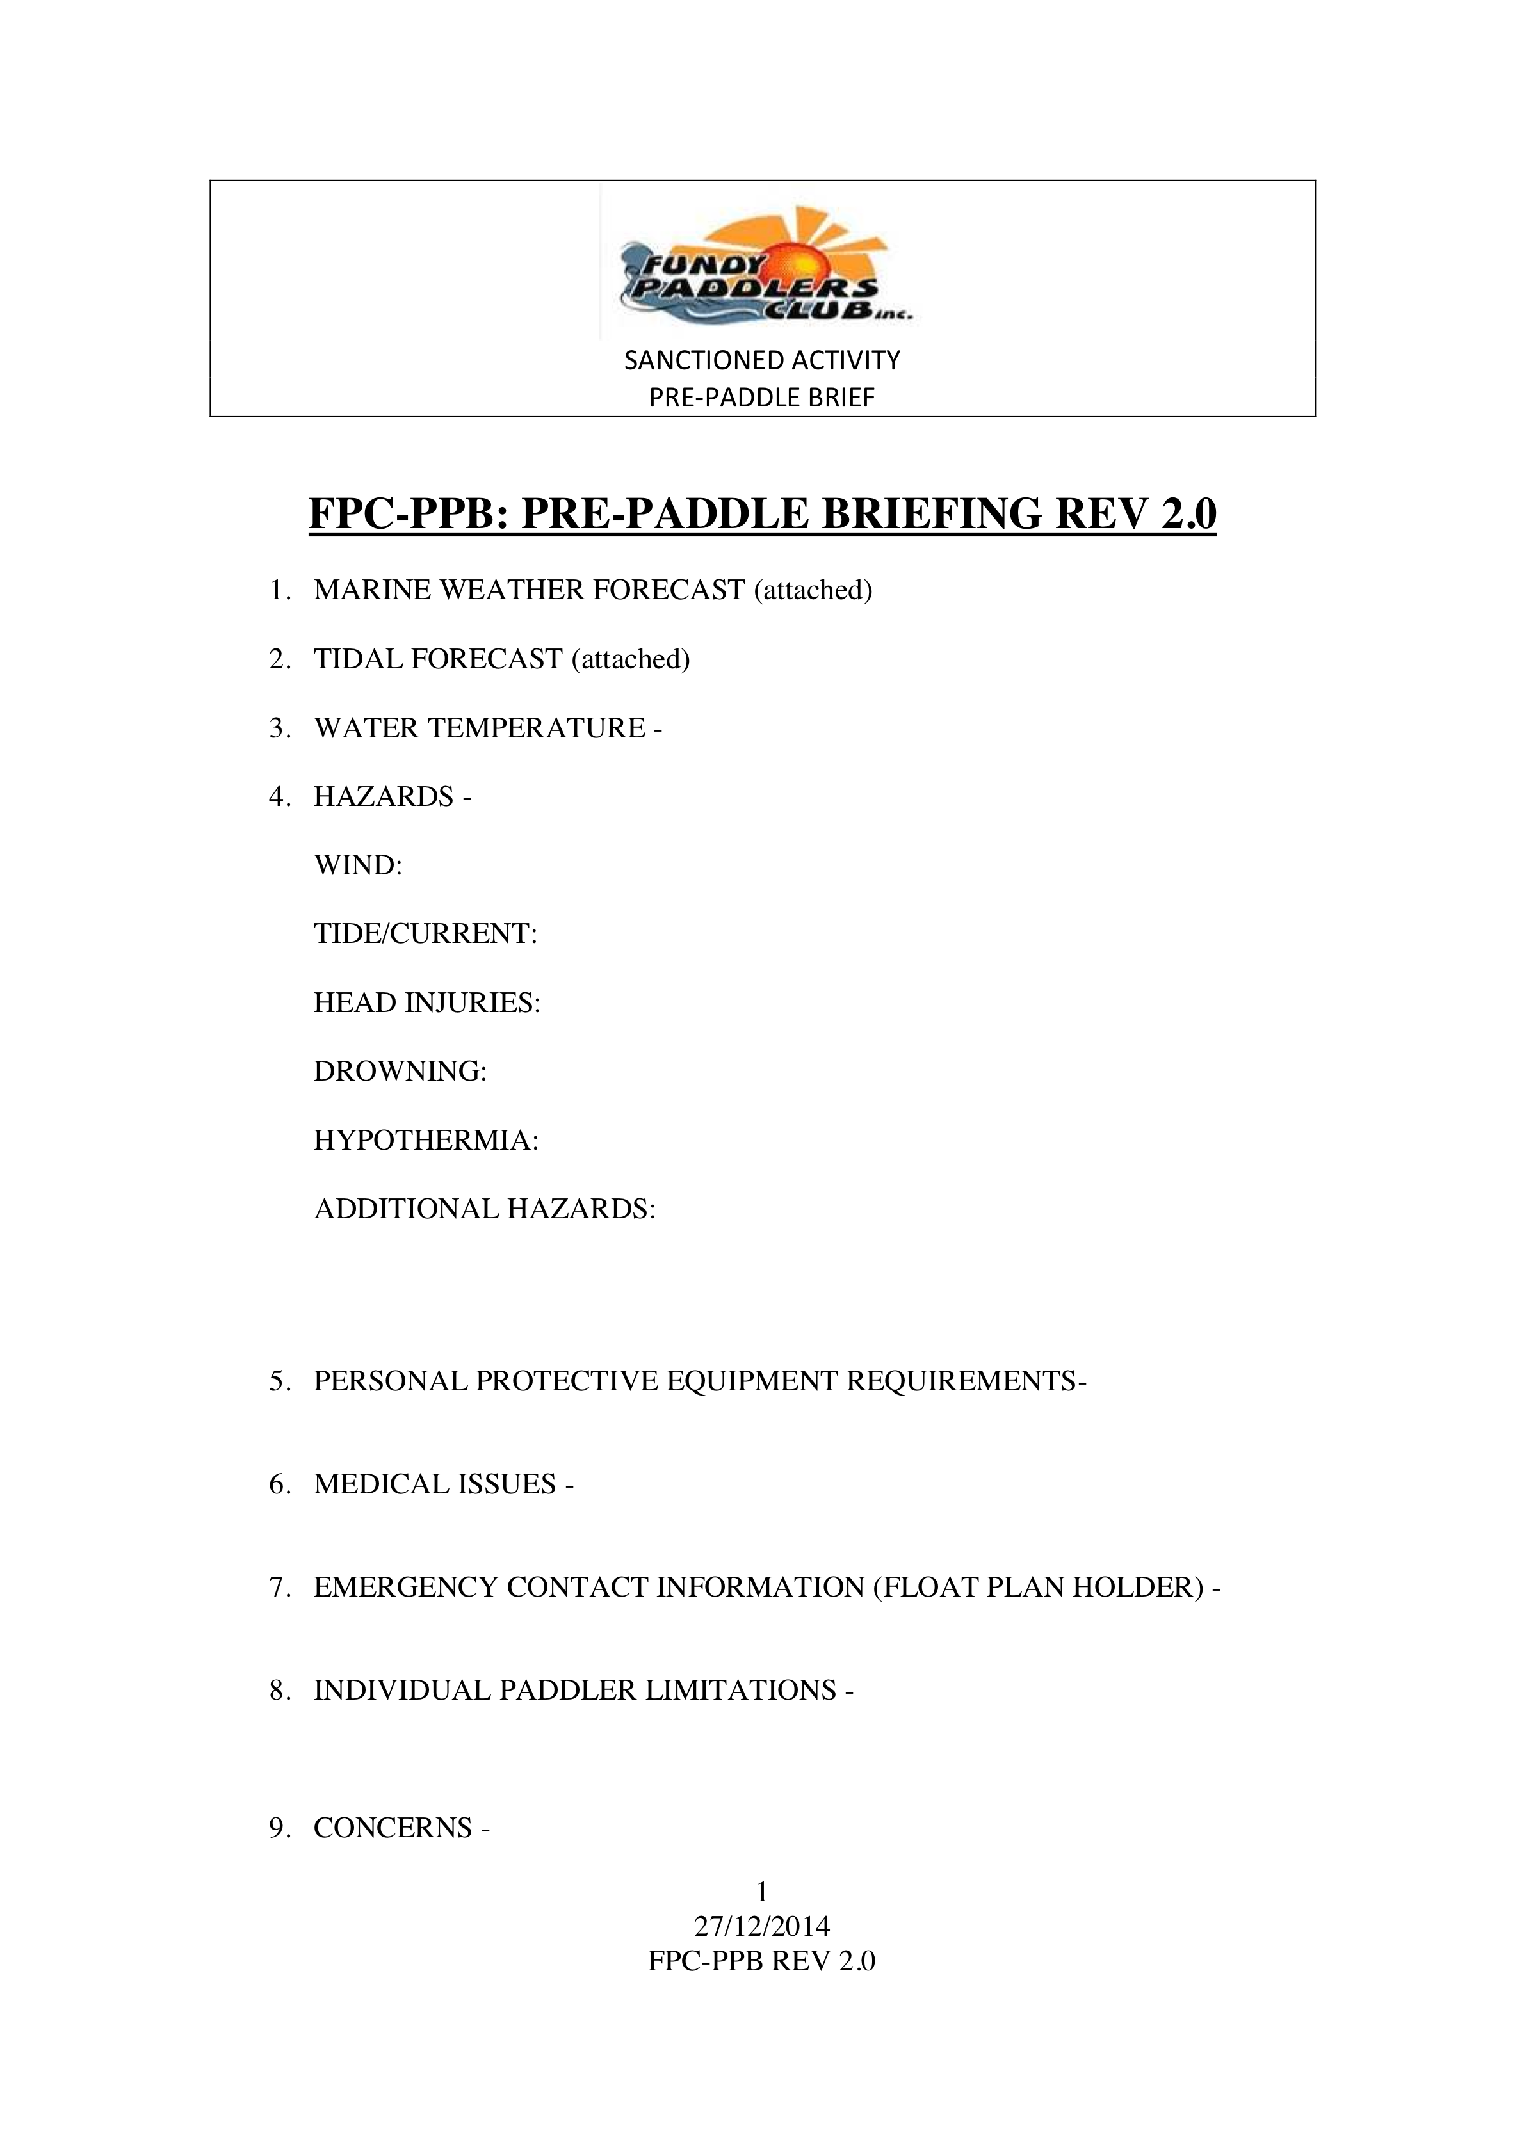
Table A-9 Serious Event Report—SAMPLE Form
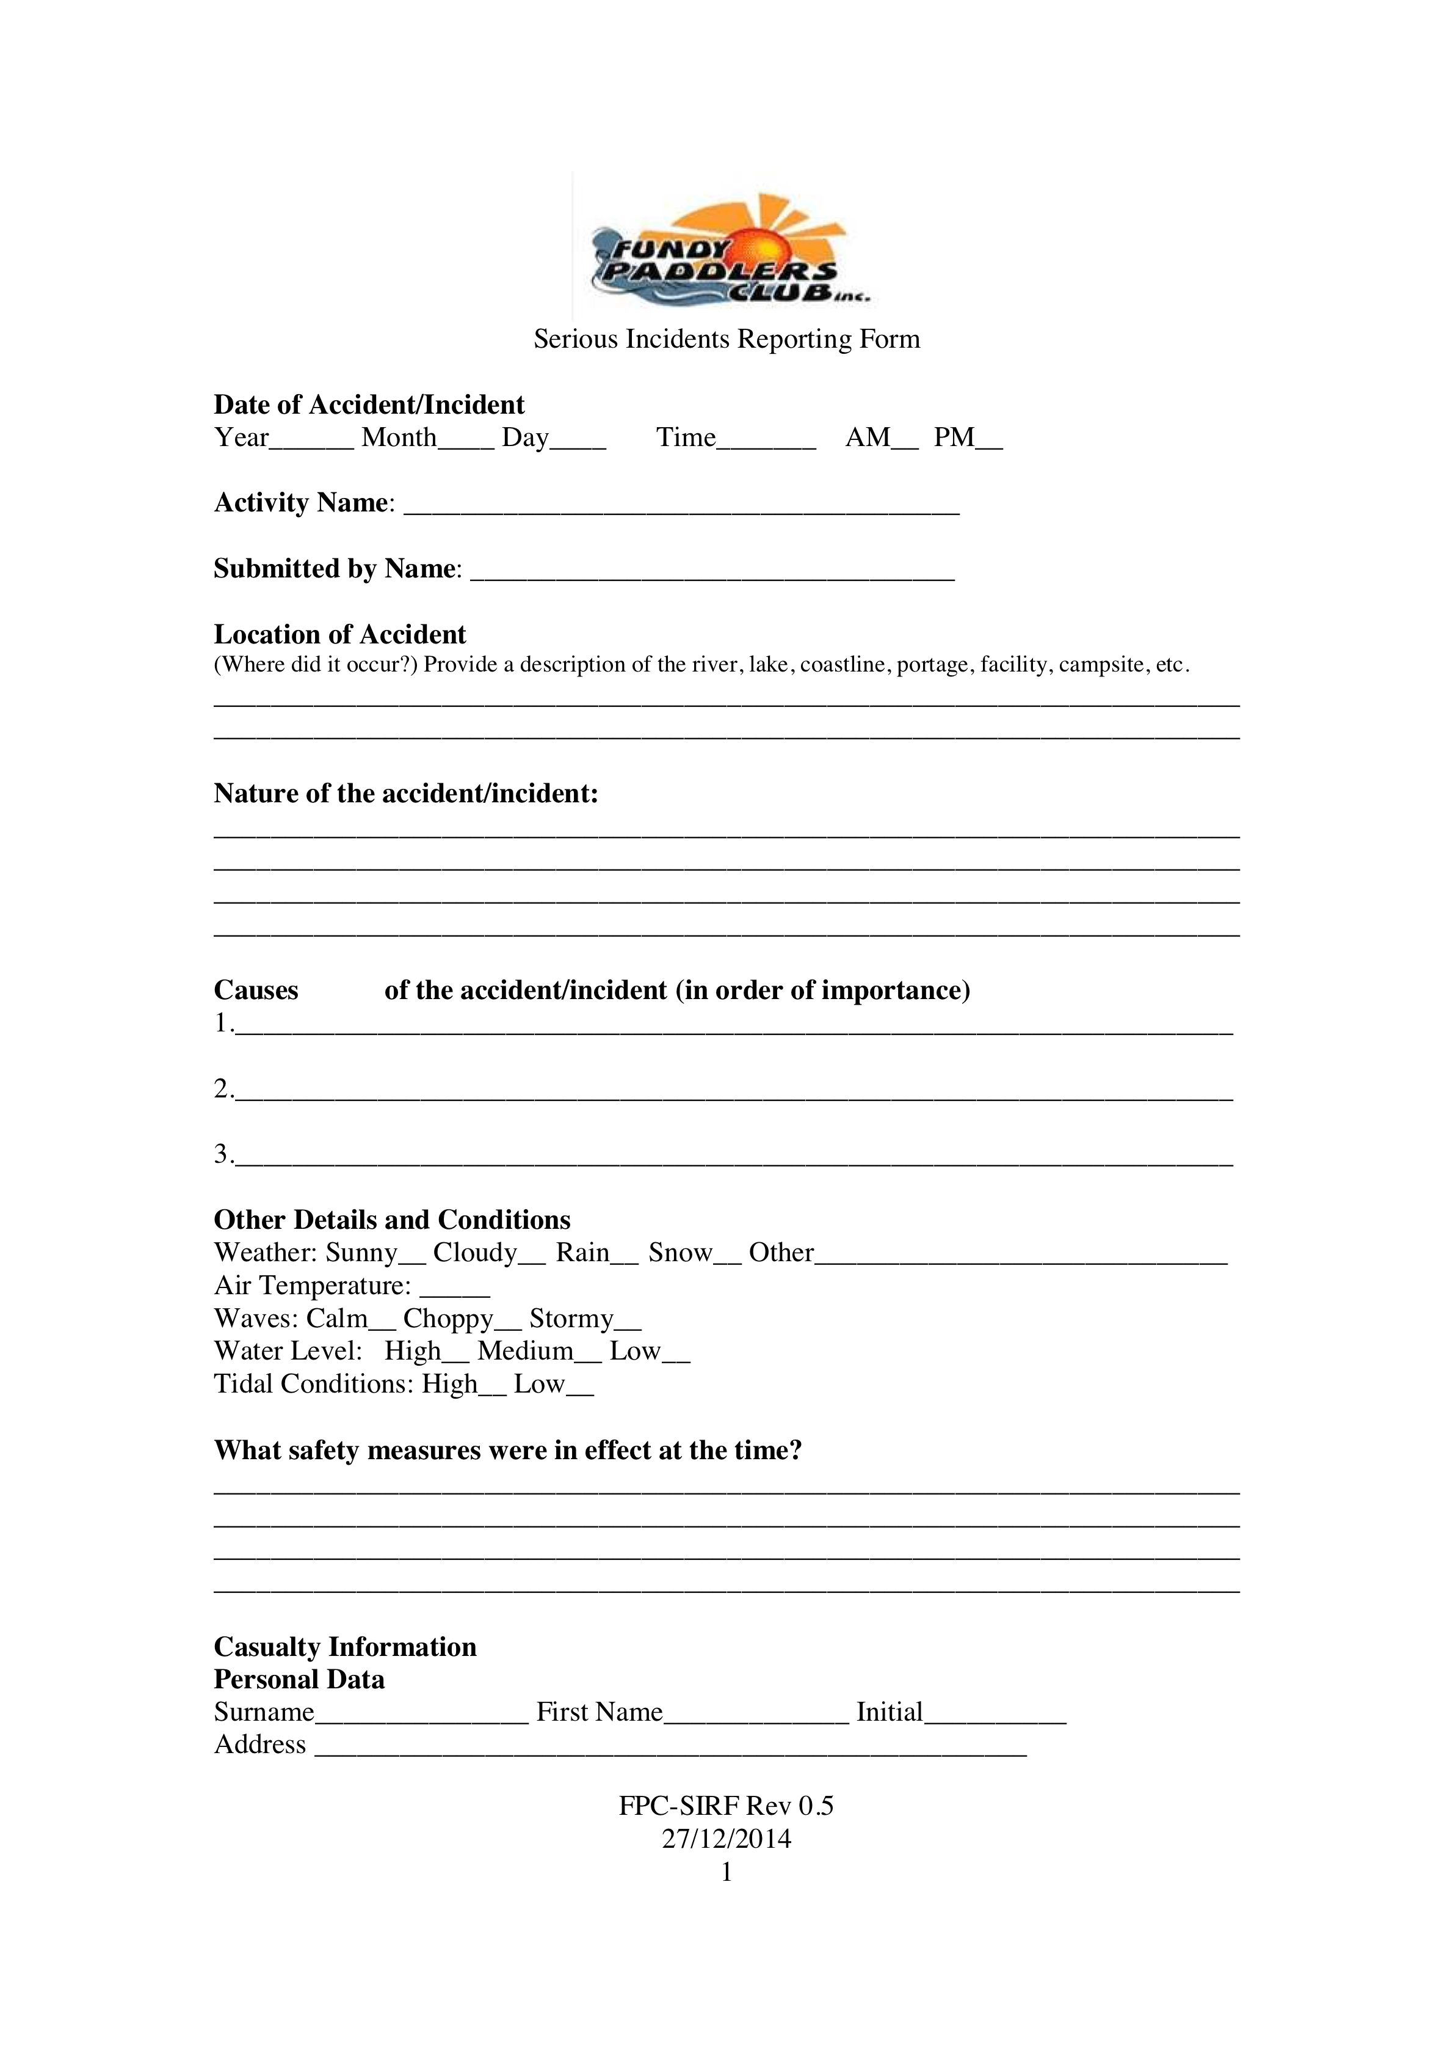

Addendum K
Canoe Tripping Resources

TABLE OF CONTENTS

1.0 Paddling Resources
  - Books
  - Web-pages
  - Courses

- Paddling Resources

1.1 Books

[1] Heed, Peter and Mansfield, Dick; (Marathon) Canoe Racing, Acorn Publishing, 1992

[2] Ray, Slim; The Canoe Handbook, Stackpole Books, 1992

[3] Dillon, Pamela, Oyen, Jeremy, Canoeing (ACA publication), Human Kinetics, 2008

[4] McGuffin, Gary and Joanne, Paddle your own Canoe, Boston Mills, 1999

[5] Mason, Paul, Scriver, Mark, Thrill of the Paddle, Key Porter books, 1999,

[6] Mason, Bill; Song of the Paddle, Key Porter Books, 1988,

[7] Guillion, Laurie, ACA Instruction Manual, Canoeing and Kayaking, 1987

[8] River Rescue
a) Bechdel, Les and Ray, Slim. River Rescue, Appalachian Moutain Club, 1985

b) Ostis, Nate; River Rescue (Pocketbook); Stackpole Books, 2010

[9] Burke, Shawn; Introduction to Paddling Styles (PDF draft on the Maine canoe Symposium web page)
on the FPC member archive page: http://fundypaddlersclub.wix.com/fundy-paddlers-club#!Policy-and-Member-Archive/c14yr/BasicPostsItem2_i3eyvnhu25_2 )

[10] Camping technique:
a) Jacobson, Cliff; Camping’s Top Secrets; Morris Book Publishing, 1998
b) Jacobson, Cliff; Boundary Waters Canoe Camping, 2012
c) Jacobson, Cliff; Canoeing and Camping: Beyond the basics, Alcon Guide, 2007
d) Gent, Tim; Canoe Camping; 2015
e) Mason, Bill; Song of the Paddle, Key Porter Books, 1988,

[11] Knots
a) Toss, Brion; Knots for Boaters, Hearts Books, 1990
b) Pawson, Des; Knots and Splices, Prospero Books, 2004

[12]Navigation
- Touche, Fred; Wilderness Navigation Handbook , Touche Publishing, 2004
- Canterbury, David; Basic & Primitive Navigation: A Waterproof Folding Guide To Wilderness Skills & Techniques; Waterford Press, 2013,
- Wells, Darran; NOLS Wilderness Navigation ; Stackpole Books, 2013,
- Tristan Cooley: UK author; Check online for recent Cooley books.

[13] Food
    - a) Weimer, Dian; The Paddling Chef, The Helconia Press, 2008
    - b) Hodgens, Carol; Wanapitei:Canoe Trippers Cookbook

[14] Paddling fitness
- Widman, Erin, Sleeping Bag Yoga, Sasquatch Books, 1999

[15] Clothing TBD

- Web sites

- Beaufort wind scale - http://www.ec.gc.ca/meteo-weather/default.asp?lang=En&n=80C039A3-1

- Basic Introduction -- paddling and canoe tripping
- Burke, Shawn, Introduction to Paddling Styles: PDF draft on the Maine canoe Symposium page; also on the FPC member archive page:
http://fundypaddlersclub.wix.com/fundy-paddlers-club#!Policy-and-Member-Archive/c14yr/BasicPostsItem2_i3eyvnhu25_2
- Canadian Canoe Routes - http://www.myccr.com/
- Canoe Tripping Net - http://www.canoetripping.net/forums/
- Paddle Canada - http://www.paddlingcanada.com/
- Paddle Performace: http://www.greenval.com/buy_paddle.html
- Canoe Camping: http://www.canoeing.com/beginner/
- Trip Planning (& what to pack):
http://www.canoeing.com/beginner/tripplanning/index.htm

- Canoe Manufacturers
- Esquif Canoes - http://www.esquif.com/en/index/
- Nova Craft Canoes - http://www.novacraft.com/default.shtml
- Old Town Canoes - http://www.oldtowncanoe.com/
- Swift Canoe - http://www.swiftcanoe.com/
- Winona - https://www.wenonah.com/

- FOOD:
a) Camp Cookery:
http://canoesaskatchewan.rkc.ca/survival/food.htm

b) Survival Food Sources:
http://www.bridensolutions.ca/food?gclid=CL3k_KSgwsMCFRc8gQodyTMAwA

- GEAR—Miscellaneous
a) Tarps http://www.cookecustomsewing.com/
b) Canoe bags:
http://ostromoutdoors.com/paddle-sports-ostrom-canoe-packs-c-22_27.html?osCsid=
- Spray decks http://www.northwater.com/html/products/canoeing/spray-decks.html
- Therm-A-Rest - http://www.cascadedesigns.com/therm-a-rest
- GSI - http://www.gsioutdoors.com/products/cat/camp_cookware/
- MEC - http://www.mec.ca/Main/home.jsp MSR - http://www.cascadedesigns.com/MSR

- Navigation
- Kirtley, Paul; Blog and facebook group: http://l.facebook.com/l/zAQGx630cAQGVZU_M2HL1twJzxjs07rHHxyG2SjsEGT4KGg/paulkirtley.co.uk/
- Gooley,Tristan; http://www.naturalnavigator.com/tristan-gooley
- GMaps –Pedometer - http://www.gmap-pedometer.com/
Great for measuring canoe trip distances – simply select manual instead of for cycling or for running.

- Regulations
- Transport Canada - http://www.tc.gc.ca/publications/EN/TP511/PDF%5CHR/TP511E.pdf

- Tracking And Wilderness Survival
- http://www.wildernesscollege.com/
- Gooley, Tristan; http://www.naturalnavigator.com/tristan-gooley

- Zaveral Paddles - http://www.zre.com/

1.3 Courses

http://www.wildernesscollege.com/

